Introduction
WONDOM JAB4 is a 4-channel audio amplifier board integrated with ADAU1701 DSP and QCC3034 Bluetooth 5.0 module. Thanks to its I2S output, the JAB4 can be connected with an I2S amplifier board for 4.2 system.
In this article, we will introduce how to use JAB4 and 2x30W-TAS5754 to build an audio 4.2 system with 3-way digital crossover. This can be achieved by SigmaStudio programming or Miumax PC UI.

What we will need

Hardware
ICP5, In-circuit Programmer
JAB4, 4CH 30W audio amplifier board integrated with ADAU1701 DSP and Bluetooth V5.0
AA-AB32255, stereo 30W I2S input audio amplifier board TAS5756
Software
SigmaStudio
Miumax for JAB4, PC UI
USB Driver

SigmaStudio Programming
First, we will introduce how to get a 3-way digital crossover through SigmaStudio.
Here is the video tutorial for your reference.

Step 1, Connect JAB4 and 2x30W-TAS5754
JAB4 is an audio amplifier board integrated with ADAU1701 and Bluetooth V5.0. It provides I2S signal output, which can be transmitted to TAS5754 I2S amplifier board for system extension.
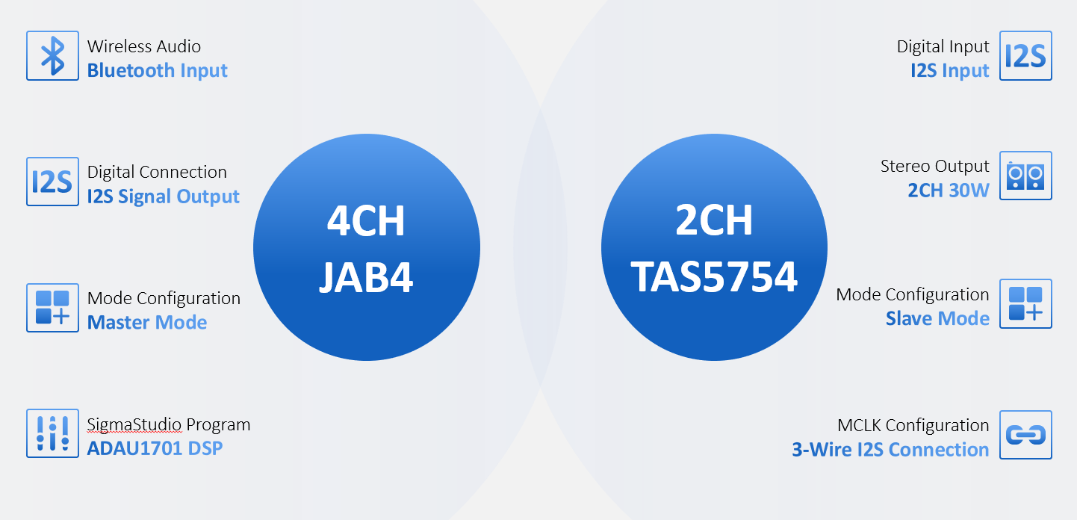
The connection diagram is as follows. It's suggested to take 2CH output of TAS5754 I2S amplifier board for treble.
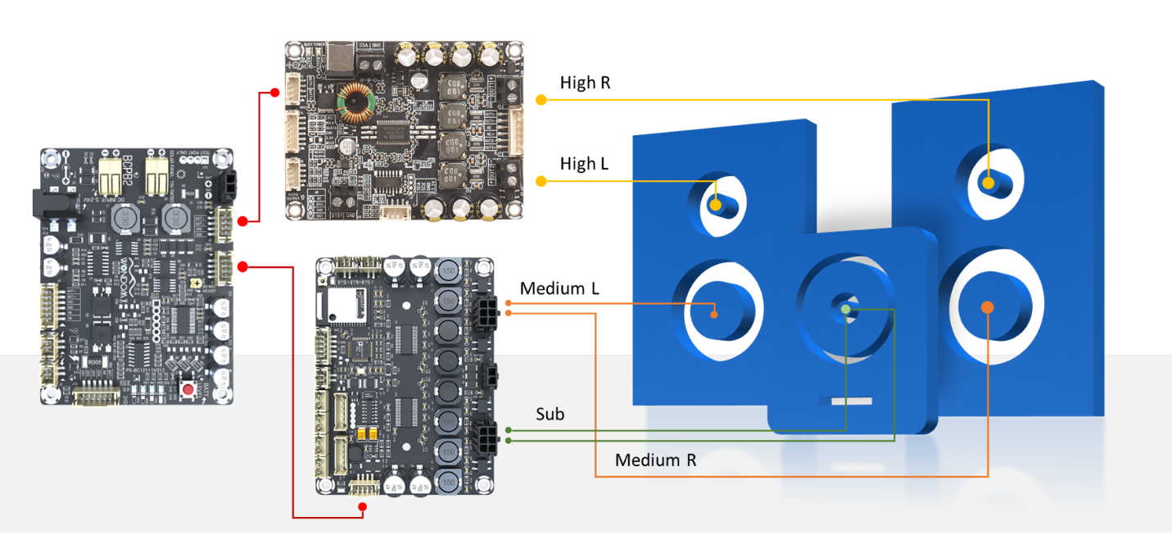
Step 2, Upgrade ICP5 Firmware and Connect it to JAB4 for Programming
Before connecting ICP5 with JAB4 for PC UI control, we need to upgrade ICP5 firmware through Miumax. After the upgrade is done, we need to set switches of ICP5 and connect it with JAB4 for programming. As for the operations, please refer to this article: SigmaStudio Programming with ICP5
Step 3, Program Modification
We have written a DSP program for this application.
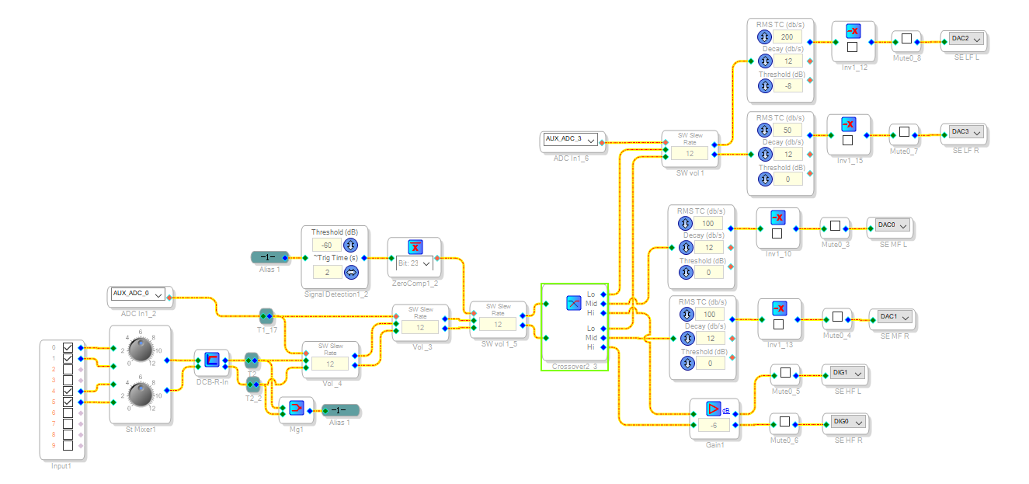
The program is uploaded for your reference. Click HERE to download it.
Set the high pass and low pass cut-off frequency according to the characteristics of your speakers. Here we set it as 180Hz and 3kHz. You can also adjust the gain.
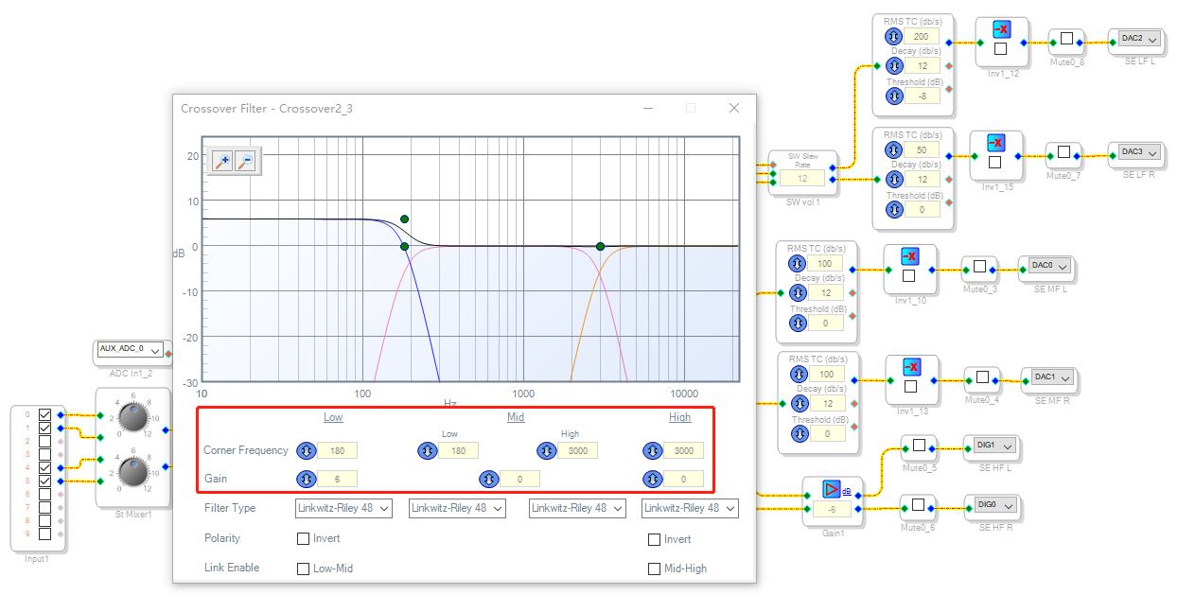
The signal flow of the 3-way digital crossover program is as flows.
Full range signal is input via Bluetooth and then goes through volume control module.
Next, signal is transmitted to crossover module, where it is divided into 3 bands according to the pre-set cut-off frequency.
Finally, signals in different frequency bands are transferred to corresponding amplifier boards.
As for the effects demonstration, please refer to this video.

PC UI Control
If you are not familiar with SigmaStudio programming, you can also make it through PC UI. As for how to achieve PC UI control of JAB4 with the ICP5 programmer, please refer to <Miumax PC UI Control With ICP5 Programmer> for detailed operations.
After JAB4 is recognized by PC UI, you can adjust the high-pass filter and low-pass filter on Miumax.
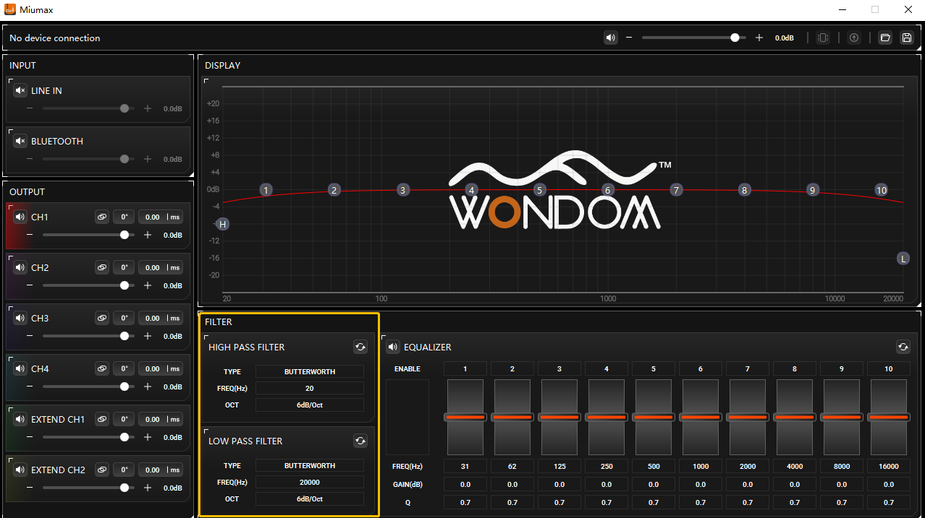
The EXTENDED CH1 & EXTENDED CH2 refer to the 2 channels of the connected I2S amplifier board.

Trouble Shooting
If Miumax doesn’t work after connecting ICP5 with JAB4, please check the operation steps.
1) Upgrade the firmware of ICP5
2) Disconnect ICP5 from PC
3) Connect ICP5 with JAB4
4) Power the system up
5) Re-connect ICP5 to PC for control

