Miumax PC UI Control with ICP5 Programmer

Introduction
ICP5 is an In-circuit programmer for use with WONDOM products integrated with DSP, providing various functions as programming with SigmaStudio, APP control and PC UI control. In addition, ICP5 supports online Firmware Upgrade. Owing to the equipped auto-identification system, ICP5 can recognize the target products automatically once they are connected.
This article aims to introduce you how to realize PC UI control of products integrated with ADAU1701 DSP. Please kindly follow the steps listed.
Applicable products: APM2, JAB3, JAB3+, JAB4, JAB5, WDSP2.4U, BDSP2.4U

Here is the video tutorial for your reference.
<https://www.youtube.com/watch?v=omNGryYGzSw>

What we will need

Hardware
ICP5, In-circuit Programmer
Products integrated with ADAU1701 DSP
- JAB2v2, Stereo or mono audio amplifier board integrated with Bluetooth V5.0 and DSP
- JAB2+, 2x50W/1x100W TPA3116 Bluetooth 5.0 Amplifier Board w TWS & Concert Mode and DSP PC UI
- JAB3, Stereo or mono audio amplifier board integrated with ADAU1701 DSP
- JAB3+, Stereo or mono audio amplifier board integrated with ADAU1701 DSP and Bluetooth V5.0
- JAB4, 4CH 30W audio amplifier board integrated with ADAU1701 DSP and Bluetooth V5.0
- JAB5, 4CH 100W audio amplifier board integrated with ADAU1701 DSP and Bluetooth V5.0
- WDSP2.4U, Unbalanced 2-In, 4-Out ADAU1701 DSP Preamp 2-Way Digital Crossover
- BDSP2.4U, ADAU1701 DSP Preamp 2-Way Digital Crossover EQ Bass Enhancement
Since the connection steps are almost the same, we will take JAB3+ as an example for demonstration.
If there is any difference or points to note, we will mark out with underline.

Software
Miumax PC UI
Model | Miumax PC UI
JAB2v2/JAB2+ | Download
ADAU1701 DSP Products :  APM2/ADAU1701 Preamp/  JAB3/ JAB3+/ JAB4/ JAB5 | Download
Step 1, Install PC UI.
Download and install the PC UI Miumax for ADAU1701 DSP products/JAB2, JAB2+.
Different product categories require different PC UI Miumax software. Please refer to the table above to download the corresponding software.
The channels can be adjusted independently.
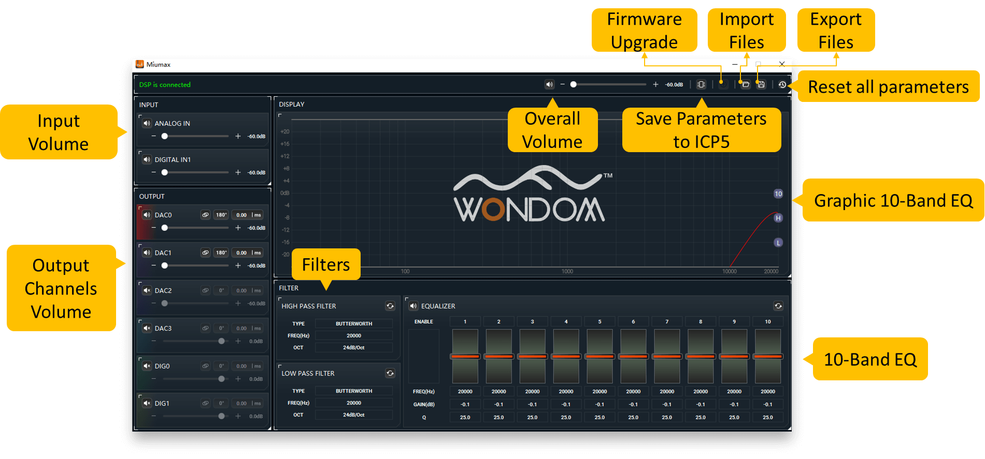
Step 2, Upgrade ICP5 Firmware.
ICP5 needs different firmware for use with different products. There is no firmware in ICP5 in default. Therefore, we need to update firmware in ICP5 for the first use with a target product.
There is no need to upgrade firmware next time you use ICP5 with the same target product, except that you use it with a different product for PC UI control.
1. Set SW1 of ICP5 at ② "Remote"
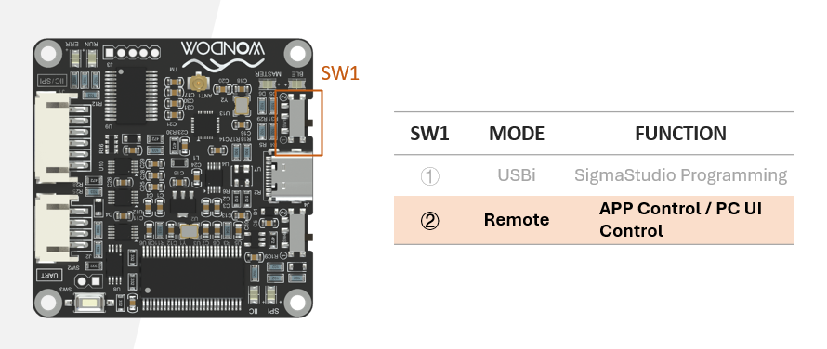
2. Press and hold on SW3 on ICP5, meantime connect ICP5 to your computer with a USB cable.
Please do not connect ICP5 with any products now.
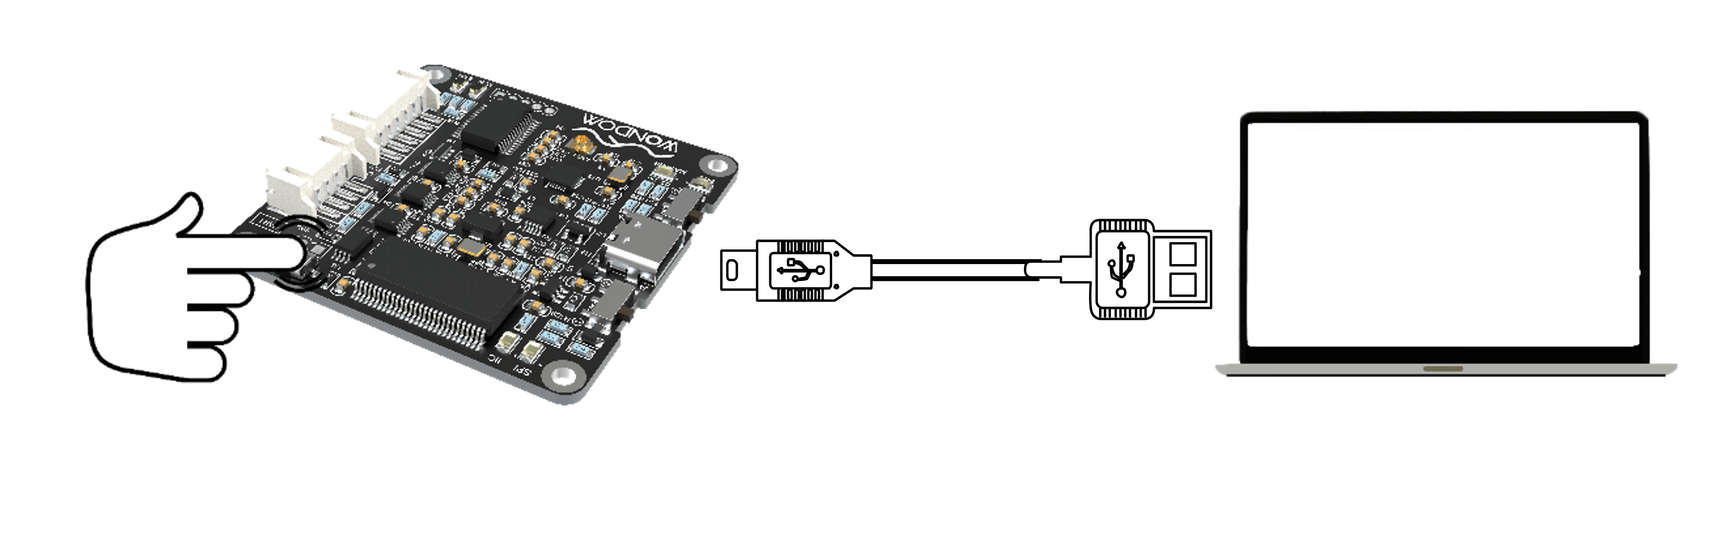
After connection with computer, if you see “RUN” indicator on ICP5 blinking, it means ICP5 has entered BootLoader mode. You can release SW3 then.
3. Run downloaded Miumax PC UI. Click "Firmware Upgrade”icon.
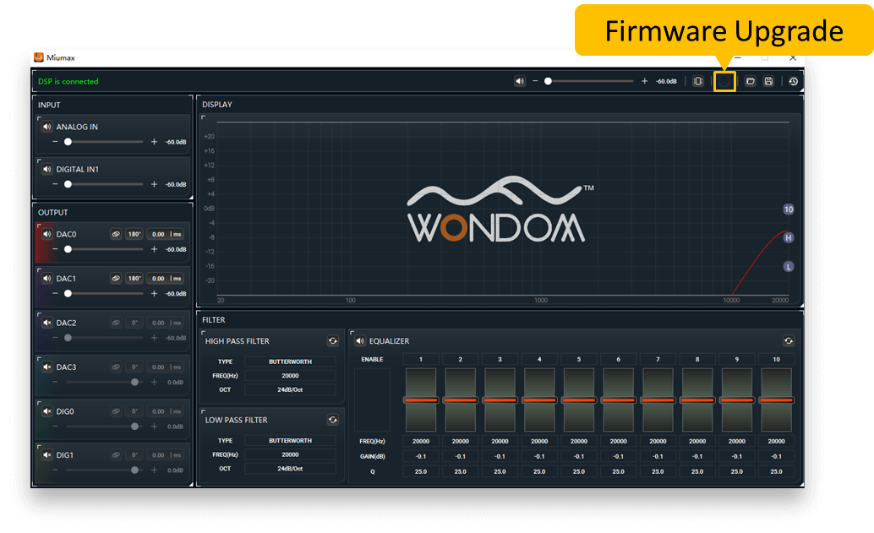
The software will automatically update the firmware of ICP5. When firmware upgrade is done, "RUN" indicator on ICP5 will turn from blinking to ON.
4. Disconnect ICP5 with the PC.

Trouble Shooting
If the ICP5 can't be recognized by the Miumax PC UI, please kindly install this USB driver and try again.
It's compatible with Win 7, Win 10 and Win 11 system.

Step 3, Build Audio System.
Build a desired audio system with the target product. Please do not power the target device now.
For products integrated with ADAU DSP, before connecting to the ICP5 for software control, it is recommended to set the volume to the minimum level using the overall volume potentiometer (POT4). If a master volume potentiometer is not available, you may short-circuit Pin 1 and Pin 2 of the overall volume port (POT4) as an alternative.
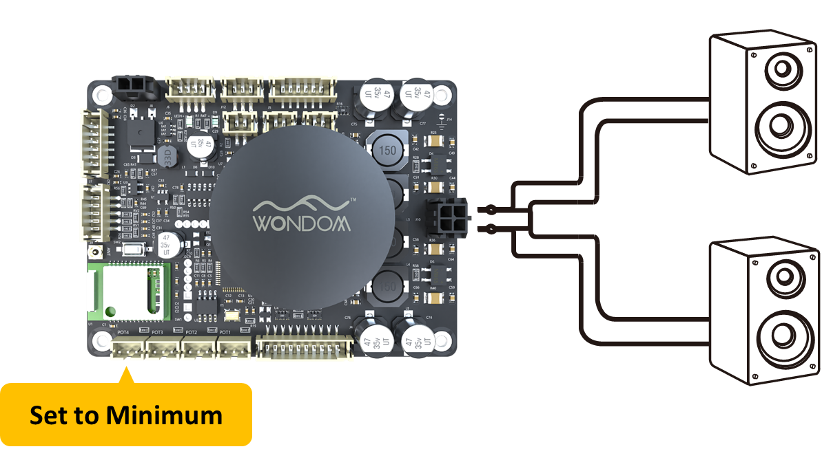

Step 4, Connect ICP5 with target device, then power the system up.
Use the PH-6Pos cable to connect the ICP5 with the target device, then power up the entire system. Do not play music now.
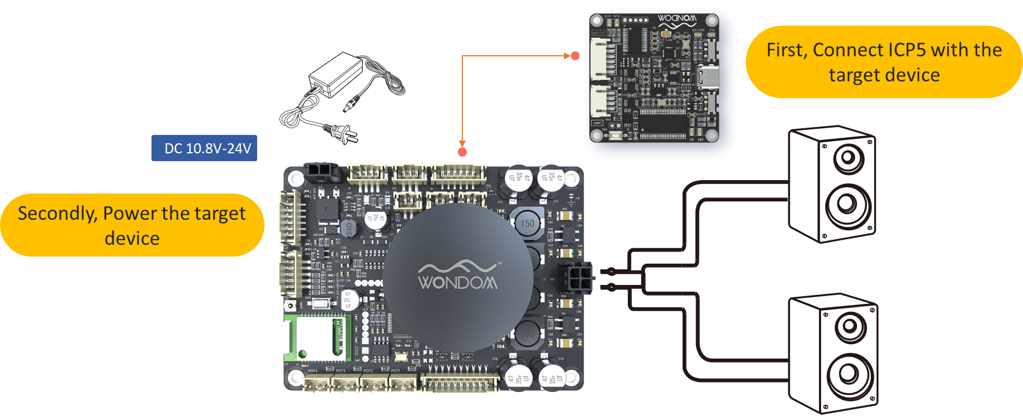

Step 5, Re-connect ICP5 to PC
Re-connect the ICP5 to your computer. If it shows "connected", it means the connection is successful.
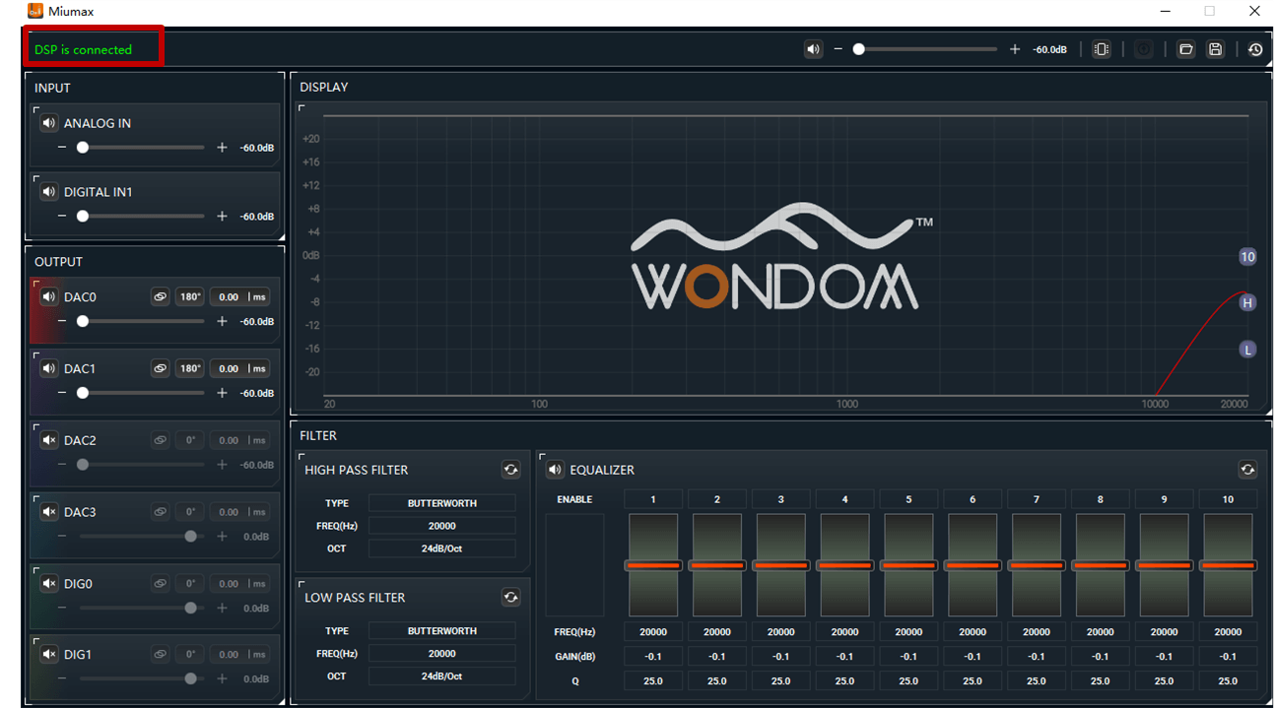
If it doesn't work successfully, please re-start the Miumax to have a trial.

Step 6, Reset parameters.
Click the "Reset" icon to reset all the parameter in the software. To avoid unexpected damage, please do not play music when resetting.
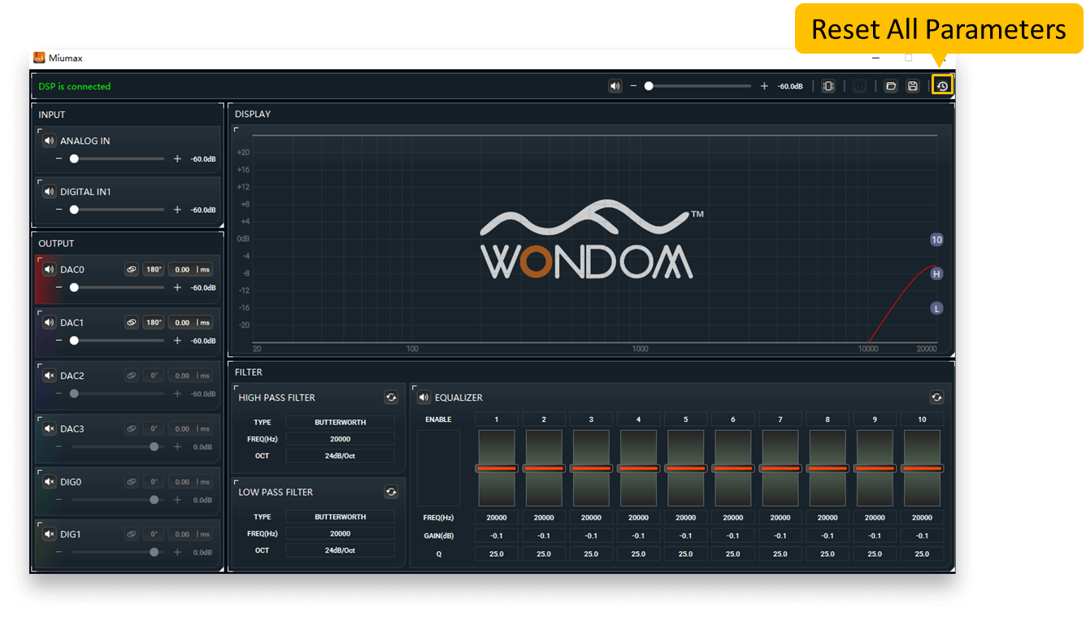
Step 7, Adjust parameters.
After resetting the parameters, connect to your audio source to play music.
To protect your speaker, we suggest setting the volume to a suitable level. It’s not suggested to be in a high level.
Then, you can adjust audio parameters properly. Please adjust slightly.

Step 8, Save parameters to ICP5.
When the adjustments are done, click “SAVE” to write the parameters. The parameters will be saved to the ICP5.
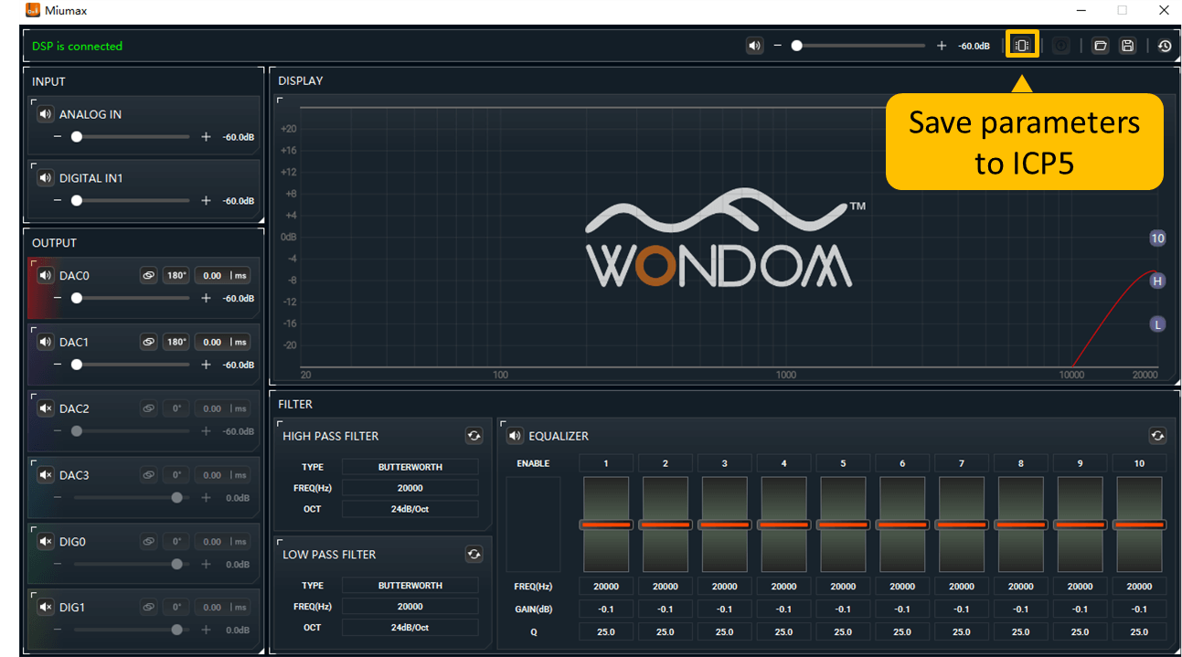
After successful saving, please disconnect the ICP5 with the PC.
As the parameters are saved in ICP5, the ICP5 needs to be connected to the target device.
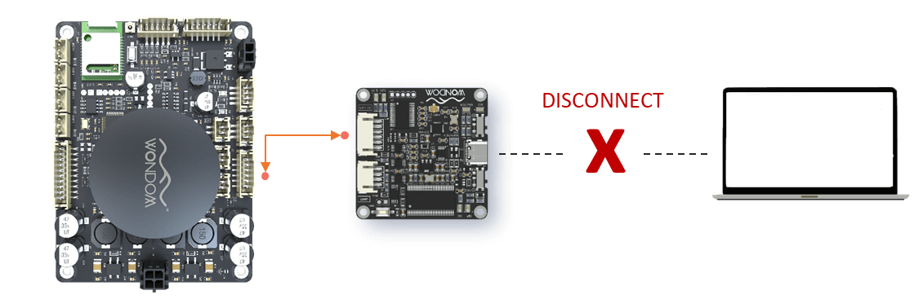
Power-Off Memory Functionality
All the PC UI parameters adjustment will be recorded in ICP5 even if it's powered off. That means, once you connect ICP5 with the target device, the kept parameters will be loaded and function to target device.

Notes
IMPORTANT NOTICES:
Please follow the steps below if the product experiences any functionality issues.
Steps for PC UI Control：
1) Download the PC UI for the target product.
2) Connect ICP5 to the PC for firmware upgrade. Do not connect ICP5 with the target product at this stage.
3) Disconnect ICP5 from the PC.
4) Connect the ICP5 with the target device (Do not power up at this stage).
5) Set the volume to the minimum level , then power up the entire system.
6) Connect the ICP5 back to the PC.
7) Ready for PC UI control.
Please note that these steps are important for troubleshooting and proper functioning of the product.
For detailed operation guide, please refer to the programming board user manual or the application notes.
- If the target product is JAB2v2, JAB2v2 will keep the parameters once you click “Save” in the software, that means, you can disconnect ICP5 from JAB2v2 after changes are completed.
- If the target products are products with ADAU1701 DSP (JAB3, JAB3+, JAB4 and JAB5), the parameters will be saved in ICP5 rather than the target devices after clicking “Save” button. Then you can run the system without connection to PC, but ICP5 needs to be connected with the target devices. After the writing is done, re-power your target device.
- All the parameters adjustment will be recorded in ICP5 even if it’s powered off. That means, once you connect ICP5 with the target device, the kept parameters will be loaded and function to target device.

